Class: Final Year B.Tech(Computer Science and Engineering)
Year: 2025-26 Semester: 1
Course: High Performance Computing Lab

Practical No. 2
PRN :- 22510079
Name : Vedprakash Patil
Batch :- B3

Title of practical: Study and implementation of basic OpenMP clauses
Implement following Programs using OpenMP with C:

Problem Statement 1: Vector Scalar Addition
Screenshots:
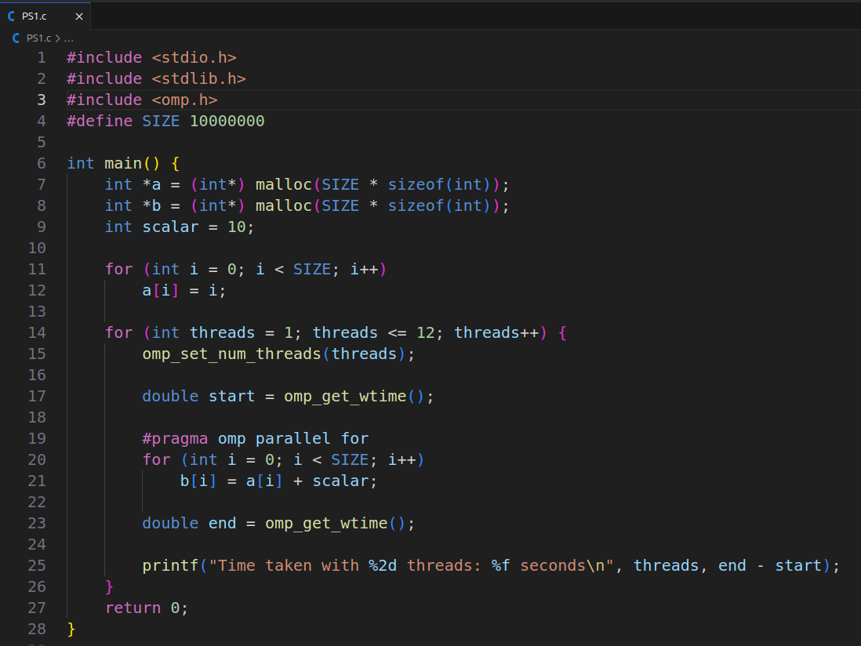

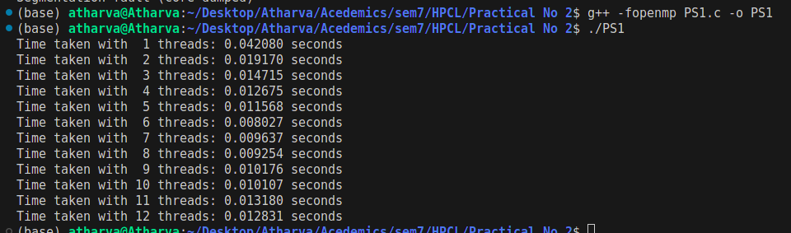
Information & Analysis : As we have 8 physcial core so we can see the decrease in time but when we are goin form the 7 to 12 there is slight increase in time the reason is the thread scheduling overhead.

Problem Statement 2: Calculation of value of Pi
Screenshots:
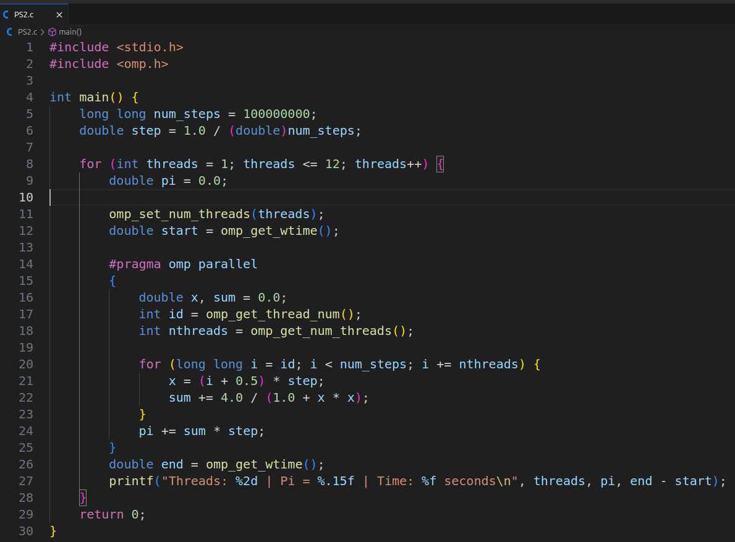
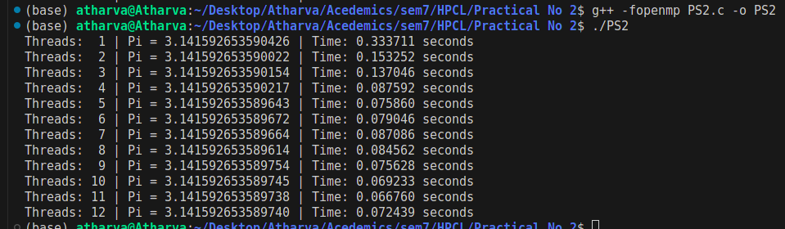
Information & Analysis: As we have 8 physcial core so we can see the decrease in time but when we are goin form the 7 to 12 there is slight increase in time the reason is the thread scheduling overhead.

